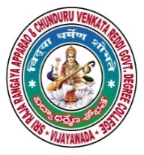 | SRR & CVR GOVERNMENT DEGREE COLLEGE  (AUTONOMOUS)  VIJAYAWADA, KRISHAN DIST., A.P  NAAC B+GRADE(CGPA:2.60) | 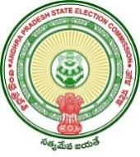

New Year Celabrations
Date: 01-01-2022
- New year celebrations on SRR & CVR college (A), Vijayawada

- Resource person: HOD’s and respected Lecturers .

- Chief Patron: Principal Dr.K.Bhagya Lakshmi.

- Events: singing,cake cutting and calendar Released.
New year celebrations were celebrated in SRR and CVR GDC(A) VJA. All the HOD’s and lecturers conveyed the best wishes to our beloved principal Dr.K . Bagya Lakshmi garu. The cake was cut by our principal and she gave a valuable message to the staff members. She advised to work with new vision and commitment and strive for the welfare of our College. The HOD’s and some of the lecturers in departments convey their wishes to students.

